Customer Food Product & Preference Analysis Dashboard
A Comprehensive Data Analytics Project Report
Author: Kavana Shree V | IBM Internship — Data Analytics | Dataset: Swiggy Food Delivery (50,000 Orders)

Table of Contents
1. Project Overview
2. Dataset Description
3. Tools & Technologies Used
4. Project Workflow — 14 Steps
5. Data Cleaning & EDA Findings
6. Key Performance Indicators
7. Food Preference Analysis
8. Time-Based Analysis
9. Customer Behaviour Analysis
10. Restaurant & Location Analysis
11. Discount Behaviour Analysis
12. Delivery Performance Analysis
13. Customer Rating Analysis
14. Dashboard Design & Features
15. Key Insights & Business Recommendations
16. How to Run the Project
17. Conclusion

1. Project Overview
This project is a comprehensive Customer Food Product & Preference Analysis Dashboard built for the IBM Data Analytics Internship. It processes and visualises 50,000 food delivery orders from Swiggy — one of India's largest food delivery platforms — to extract actionable insights about customer preferences, ordering behaviour, restaurant performance, and delivery quality.
The dashboard is built entirely in Python using Streamlit (for the web interface) and Plotly (for interactive visualisations). It is structured as a single Python file — Kavana Shree V.py — and covers 8 analytical sections accessible via a sidebar navigation panel.

Objectives of the Project
• Understand what food categories and cuisines customers most frequently order.
• Identify ordering patterns by time of day, weekday, month, and season.
• Segment customers by order frequency and total spending (Bronze, Silver, Gold).
• Analyse restaurant and city-level performance.
• Evaluate the impact of discounts on order value, quantity, and repeat purchases.
• Assess delivery performance and its relationship with customer satisfaction ratings.
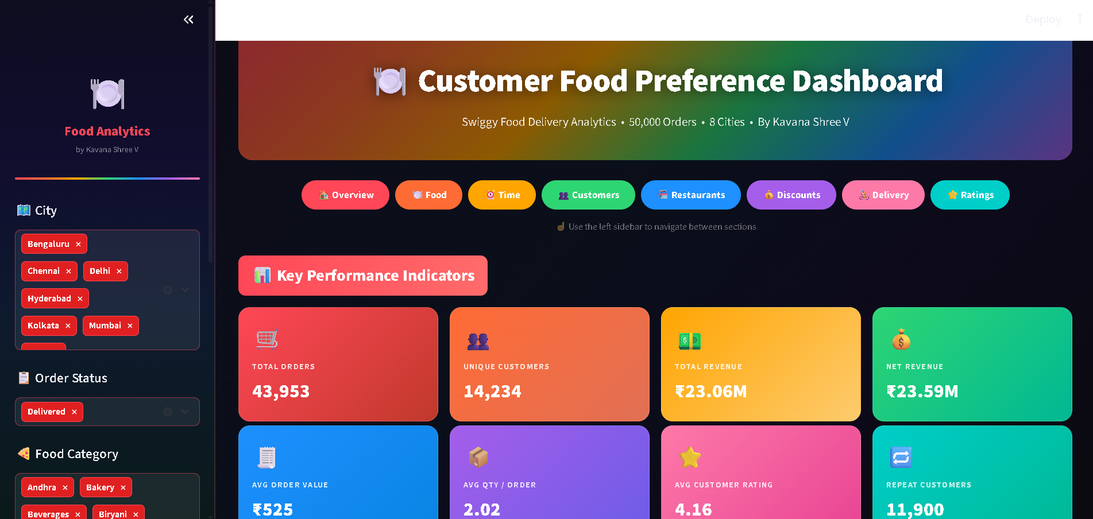

2. Dataset Description
The dataset used is swiggy_food_delivery_50000.csv — a simulated Swiggy delivery dataset containing 50,000 rows and 21 columns, spanning orders from January 2025 to August 2026. There are no duplicate records. The only missing values are 3,487 Customer_Rating entries, corresponding to Cancelled orders (which receive no rating).

Dataset Columns Summary
Column Name | Data Type | Description
Order_ID | String | Unique identifier for each order (e.g. SWG33554)
Order_Date | Date | Date when the order was placed (2025-01-01 to 2026-08-31)
Order_Time | Time | Time of day when the order was placed (HH:MM format)
Delivery_Date | Date | Date when the order was delivered
Customer_ID | String | Unique customer identifier (e.g. CUST15279)
Restaurant_ID | String | Unique restaurant identifier (e.g. REST204)
Restaurant_Name | String | Name of the restaurant (e.g. Absolute Barbecues)
City | String | City of the order — 8 Indian cities
Cuisines | String | Type of cuisine — 15 categories (Biryani, Burgers, Chinese, etc.)
Food_Category | String | Food product category — 20 types (Pizza, Beverages, Breakfast, etc.)
Quantity | Integer | Number of items ordered in a single order
Order_Value | Integer | Gross order amount in Indian Rupees (₹50 to ₹3,295)
Discount | Float | Discount applied on the order in ₹ (0 if no discount)
Delivery_Charges | Integer | Delivery fee charged to the customer in ₹
Tax | Float | Tax amount applied on the order in ₹
Net_Revenue | Float | Net revenue: Order_Value - Discount + Tax + Delivery_Charges
Payment_Method | String | Payment mode used — UPI, Card, Wallet, or Cash
Order_Status | String | Final order status — Delivered, Cancelled, or Delayed
Delivery_Time | Integer | Total delivery duration in minutes (0 to 100 mins)
Delivery_Distance | Float | Delivery distance in kilometres
Customer_Rating | Float | Customer satisfaction rating 1–5 (missing for Cancelled orders)

Dataset Quick Facts
• Total Orders: 50,000 • Date Range: January 2025 – August 2026
• Unique Customers: 14,479 • Repeat Customers (>1 order): 12,707 (87.8%)
• Cities Covered: 8 (Pune, Delhi, Bengaluru, Kolkata, Visakhapatnam, Chennai, Mumbai, Hyderabad)
• Food Categories: 20 (Beverages, Pizza, Breakfast, Healthy Food, Biryani, etc.)
• Cuisine Types: 15 (Burgers, Biryani, Seafood, Chinese, Andhra, North Indian, etc.)
• Payment Methods: UPI (54.6%), Card (25.4%), Wallet (10.1%), Cash (9.9%)
• Order Statuses: Delivered (87.9%), Cancelled (6.97%), Delayed (5.12%)
• Missing Values: 3,487 Customer_Rating (all from Cancelled orders)
• Duplicate Records: 0

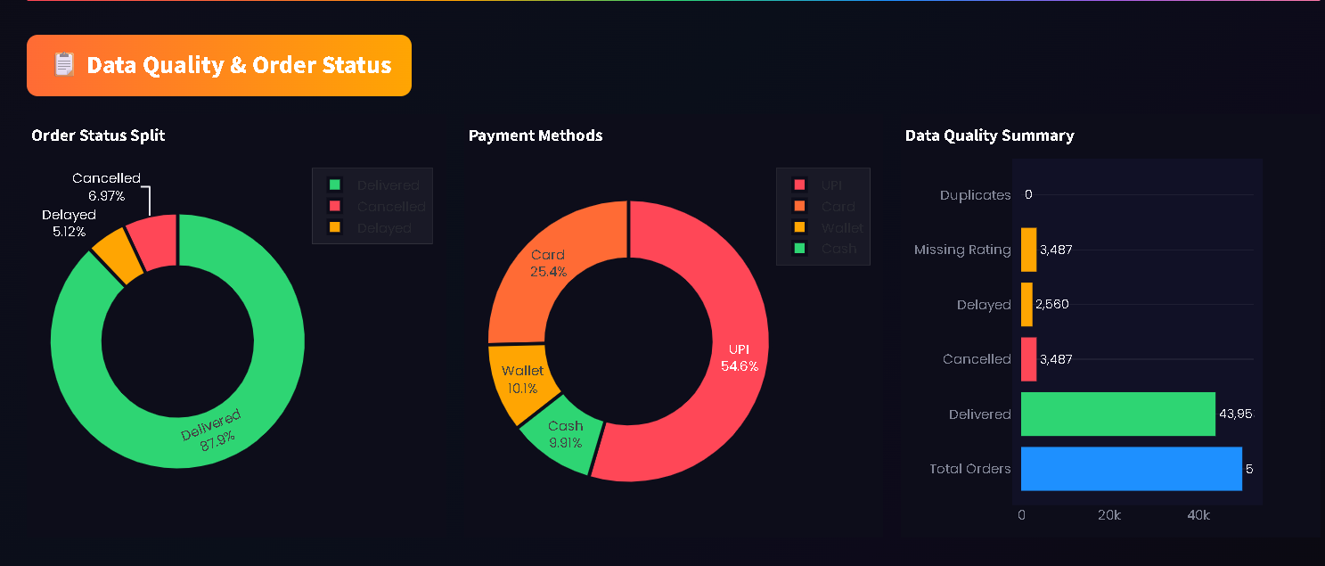

3. Tools & Technologies Used
Library / Tool | Version | Purpose
Python | 3.9+ | Core programming language for all data processing and app logic
Streamlit | >=1.35.0 | Web application framework — builds the interactive dashboard UI
Pandas | >=2.0.0 | Data loading, cleaning, feature engineering, and aggregations
NumPy | >=1.26.0 | Numerical computations and array operations
Plotly | >=5.22.0 | All interactive charts — bar, pie, scatter, heatmap, treemap, funnel, area
Statsmodels | >=0.14.0 | OLS regression trendline in Delivery Distance vs Time scatter chart

4. Project Workflow — 14 Steps
The project follows a structured 14-step data analytics workflow:

Step 1 — Environment Setup
Install Python 3.9+ and all required libraries from requirements.txt using pip install -r requirements.txt. Libraries include Streamlit, Pandas, NumPy, Plotly, and Statsmodels.

Step 2 — Data Loading
The dataset is loaded from the ZIP archive (archive (2).zip) or its extracted CSV. Streamlit's @st.cache_data decorator is used for caching so repeated filter interactions don't re-read the file.

Step 3 — Data Cleaning & EDA
Order_Date and Delivery_Date are parsed as datetime. Order_Time is parsed as HH:MM time. Missing values are identified (3,487 Customer_Rating). Duplicate check confirms 0 duplicates. Order_Status, Food_Category, Cuisines are validated as categorical columns.

Step 4 — Feature Engineering
New columns derived from the raw data: Hour (0–23), Weekday (Monday–Sunday), Month, Month_Num, Year, IsWeekend flag, Season (Winter/Spring/Summer/Autumn), TimeOfDay (Morning/Afternoon/Evening/Night), HasDiscount (True/False), ValueSegment (5 price bins), CustomerSegment (Bronze/Silver/Gold based on net revenue quartiles).

Step 5 — KPI Computation
Eight headline KPIs computed: Total Orders, Unique Customers, Total Revenue, Net Revenue, Avg Order Value, Avg Quantity/Order, Avg Customer Rating, Repeat Customers count.

Step 6 — Food Preference Analysis
Orders and revenue aggregated by Food_Category and Cuisines. Treemaps, horizontal bar charts, histograms, and pie charts show distribution of orders and revenue across 20 food categories and 15 cuisines.

Step 7 — Time-Based Analysis
Orders analysed by Hour (0–23), Time of Day (Morning/Afternoon/Evening/Night), Weekday, Month, Season. A Weekday x Hour heatmap reveals peak ordering windows. Stacked bar charts show food category preferences at each time of day.

Step 8 — Customer Behaviour Analysis
Customer-level aggregation computes TotalOrders, TotalSpend, AvgSpend, FavouriteCategory, FavouriteCuisine per customer. RFM-style scatter (orders vs total spend) coloured by segment reveals Gold, Silver, and Bronze customer clusters.

Step 9 — Restaurant & Location Analysis
City-wise orders, revenue, and customer count aggregated. Top restaurants ranked by orders with an interactive slider. Cuisine distribution visualised per city. Restaurant scatter (orders vs revenue, bubble = avg value) shows performance.

Step 10 — Discount Behaviour Analysis
Discounted vs non-discounted orders compared on avg value and quantity. Scatter of discount amount vs order value. Repeat vs one-time customers compared on discount rate. Average discount by food category and cuisine charted.

Step 11 — Delivery Performance Analysis
Delivery time and distance distributions visualised. Scatter plot of Distance vs Time with OLS trendline. City-level avg delivery time and delay percentage charts. Avg delivery time by food category.

Step 12 — Rating Analysis
Rating distribution charted as bar and funnel. Avg rating by food category, cuisine, delivery time bucket, order value segment, and payment method. Top-rated restaurants (minimum 50 orders) identified.

Step 13 — Dashboard Styling & UX
Custom CSS applied: dark background (#0a0a0f), Poppins font, gradient hero banners, colour-coded KPI cards (8 different gradient colours), rainbow dividers, coloured section headers, styled sidebar navigation buttons, vivid red multiselect tags.

Step 14 — Validation & Launch
Python AST syntax check run on the final file confirms no syntax errors. Data pipeline logic tested independently. App launched with python -m streamlit run 'Kavana Shree V.py' and verified at http://localhost:8501.

5. Data Cleaning & EDA Findings
Check Performed | Result | Action Taken
Missing Values | 3,487 Customer_Rating missing | Retained — correspond to Cancelled orders (expected)
Duplicate Records | 0 duplicates found | No action required
Data Type — Order_Date | Object (string) | Converted to datetime using pd.to_datetime()
Data Type — Order_Time | Object (string) | Parsed with format='%H:%M' to time
Cancelled Orders | 3,487 (6.97%) | Excluded from rating analysis; retained for other analyses
Delayed Orders | 2,560 (5.12%) | Flagged; included in delivery performance analysis
Outliers — Delivery_Time | Min=0, Max=100 min | Retained as valid edge cases
Outliers — Order_Value | Min=₹50, Max=₹3,295 | Retained; binned into ValueSegment for analysis

6. Key Performance Indicators (KPIs)
The dashboard displays 8 headline KPIs on the Overview page using colour-coded gradient cards. These KPIs are dynamically recalculated based on the active sidebar filters (city, status, category, and date range).
KPI | Value (Full Dataset — Delivered) | Card Colour
Total Orders | 43,953 (Delivered only) | Red gradient
Unique Customers | 14,479 | Orange gradient
Total Revenue (Order Value) | ~₹23.09M | Yellow gradient
Net Revenue | ~₹24.89M | Green gradient
Avg Order Value | ₹525.58 | Blue gradient
Avg Quantity per Order | 2.46 items | Purple gradient
Avg Customer Rating | 4.11 / 5.00 | Pink gradient
Repeat Customers | 12,707 (87.8%) | Teal gradient

7. Food Preference Analysis
This section answers the core question: What do customers like to eat? It analyses Food_Category, Cuisines, Quantity, and Order_Value.

Key Findings:
• Beverages (2,571) and Pizza (2,551) are the most ordered food categories, closely followed by Breakfast and Healthy Food.
• All 20 food categories are nearly evenly distributed (~2,430–2,571 orders each), indicating no single dominant category.
• Burgers (3,422) and Biryani (3,414) are the top cuisines by order count.
• Average order value is ₹525.58 (range: ₹50 to ₹3,295). The distribution is right-skewed with most orders between ₹200–₹700.
• ₹200–₹400 is the most common value segment (33.7% of orders), followed by ₹400–₹700 (28.8%).
• Revenue treemap shows Burgers and Biryani dominate total cuisine-level revenue.
Charts in this section: Orders by Food Category (horizontal bar), Revenue by Food Category (horizontal bar), Orders by Cuisine (horizontal bar), Revenue Treemap by Cuisine, Order Value Histogram, Orders by Value Segment (pie), Avg Quantity per Food Category, Total Quantity by Cuisine.

8. Time-Based Analysis
This section identifies when customers are most active. Features extracted: Hour (0–23), TimeOfDay, Weekday, Month, Season, with a Weekday x Hour heatmap as the signature visualisation.

Key Findings:
• Peak ordering hours: 18:00–22:00 (Evening & Night) account for the highest order volumes, with 19:00–20:00 being the busiest single hour.
• Evening (17:00–21:00) is the single largest time-of-day segment.
• Saturday and Sunday show the highest order counts compared to weekdays.
• Monthly trend shows consistent growth from Jan 2025 through Aug 2026.
• Summer (June–August) has the highest seasonal order volume.
• The Weekday x Hour heatmap reveals that Friday & Saturday evenings (18:00–22:00) are the absolute peak windows.
• Morning orders (5:00–12:00) are dominated by Breakfast and Beverages; Night orders favour Biryani and Fast Food.
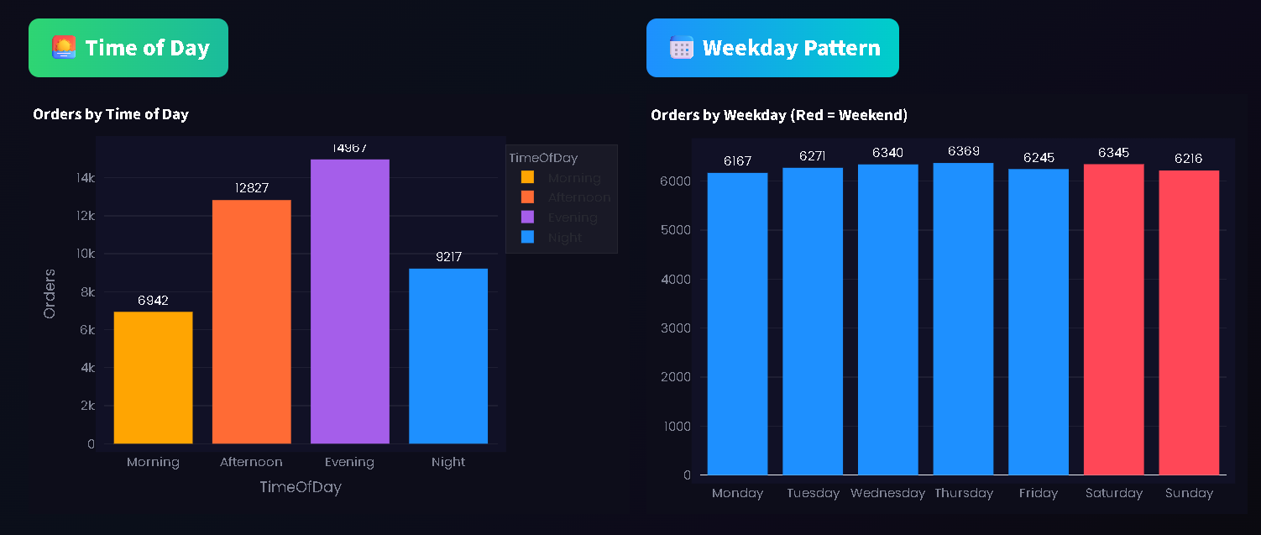
Charts in this section: Hourly Orders & Revenue (dual-axis), Time of Day bar, Weekday bar (weekends highlighted red), Monthly area trend, Seasonal bar, Weekday x Hour heatmap, Food Category stacked by Time of Day.

9. Customer Behaviour Analysis
Each customer is aggregated to compute: TotalOrders, TotalSpend, AvgSpend, FavouriteCategory, FavouriteCuisine, and CustomerSegment. Segment thresholds are based on net revenue quartiles: Bronze (<=Q1), Silver (Q1–Q3), Gold (>Q3).

Key Findings:
• 87.8% of customers are repeat buyers (placed more than 1 order).
• Avg orders per customer: 3.45; max orders by a single customer: 12.
• Gold segment customers spend 3x more on average than Bronze customers.
• Silver segment is the largest (49.1% of customers), followed by Gold (38.6%), Bronze (12.4%).
• Beverages, Pizza, and Biryani are the most common favourite food categories across customers.
• The RFM scatter clearly separates the three segments, with Gold customers clustered at high orders + high spend.
Charts: Order frequency histogram, Avg spend histogram, Customer segment pie, Segment vs spend bar, Favourite category/cuisine bar, RFM scatter (orders vs spend, coloured by segment).
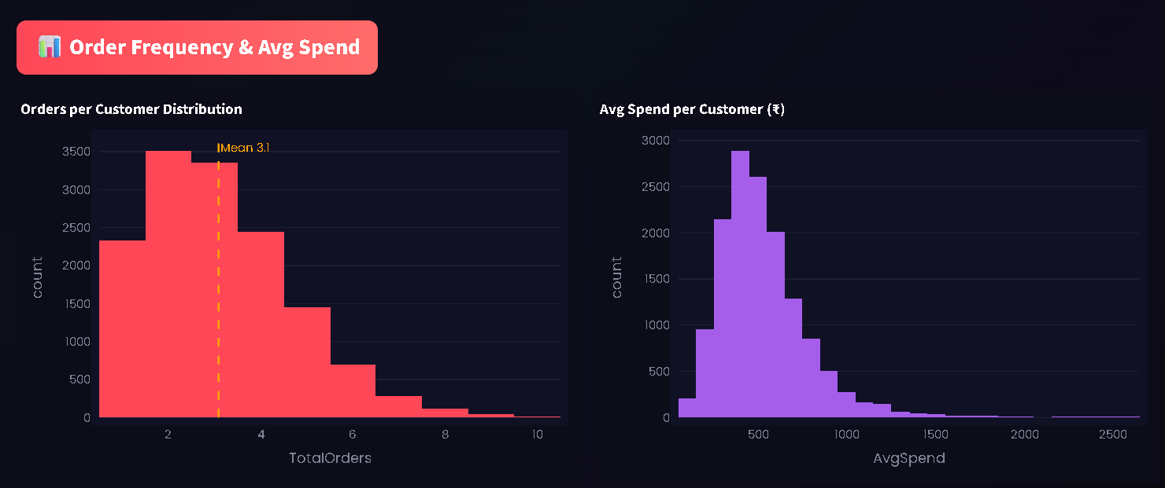

10. Restaurant & Location Analysis

Key Findings:
• Pune (6,346) and Delhi (6,320) lead in total order volume, with all 8 cities closely clustered between 6,100–6,350 orders.
• Absolute Barbecues (1,248 orders) and Saravana Bhavan (1,180 orders) are the top two restaurants by volume.
• Cuisine preferences vary by city — Hyderabadi cuisine leads in Hyderabad; South Indian dominates Bengaluru and Chennai.
• All cities maintain similar average customer ratings (~4.1/5.0), indicating consistent service quality nationwide.
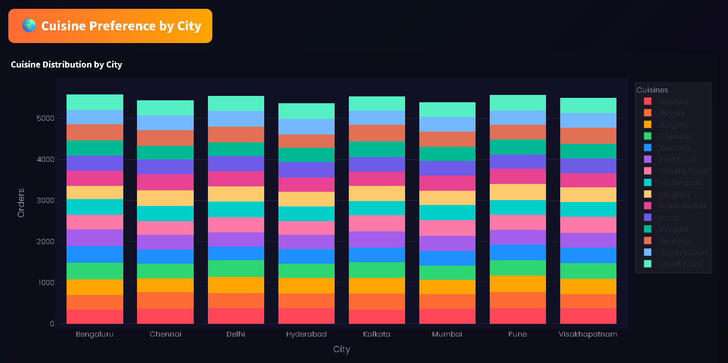
Charts: City orders bar, City orders vs revenue bubble chart, Cuisine by city stacked bar, Top-N restaurants bar (interactive slider), Restaurant orders vs revenue scatter, Avg rating by city.

11. Discount Behaviour Analysis

Key Findings:
• Approximately 47% of all orders include a discount.
• Discounted orders have a marginally higher average quantity than non-discounted orders.
• Avg order value with discount is slightly higher (~₹530) vs without discount (~₹521), suggesting discounts attract higher-value orders.
• Repeat customers use discounts at a similar rate to one-time customers — discount does not appear to be the sole driver of repeat purchases.
• Discount amounts are fairly uniform across food categories and cuisines (~₹25–₹30 avg discount).
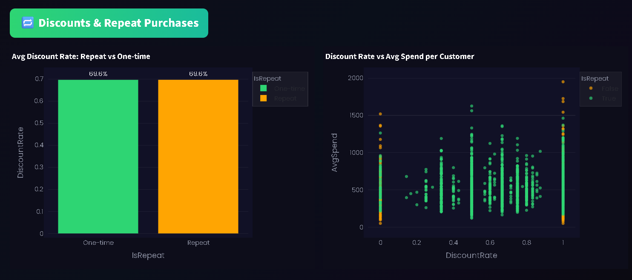
Charts: Discount vs no-discount comparison bar, Discount amount vs order value scatter, Repeat vs one-time discount rate bar, Discount rate vs avg spend scatter, Avg discount by category and cuisine.

12. Delivery Performance Analysis

Key Findings:
• Average delivery time: 33.7 minutes (range: 0–100 minutes).
• Average delivery distance: ~5.5 km.
• OLS trendline confirms a positive correlation: longer distance = longer delivery time.
• Delayed orders appear scattered throughout all distance ranges — delays are not purely distance-driven.
• Delivery times are consistent across all 8 cities (avg ~33–34 min per city).
• Delay rates are similarly distributed across cities (~5% each).
Charts: Delivery time histogram, Distance histogram, Distance vs Time scatter (OLS trendline), Avg delivery time by city, Delay % by city, Avg delivery time by food category.
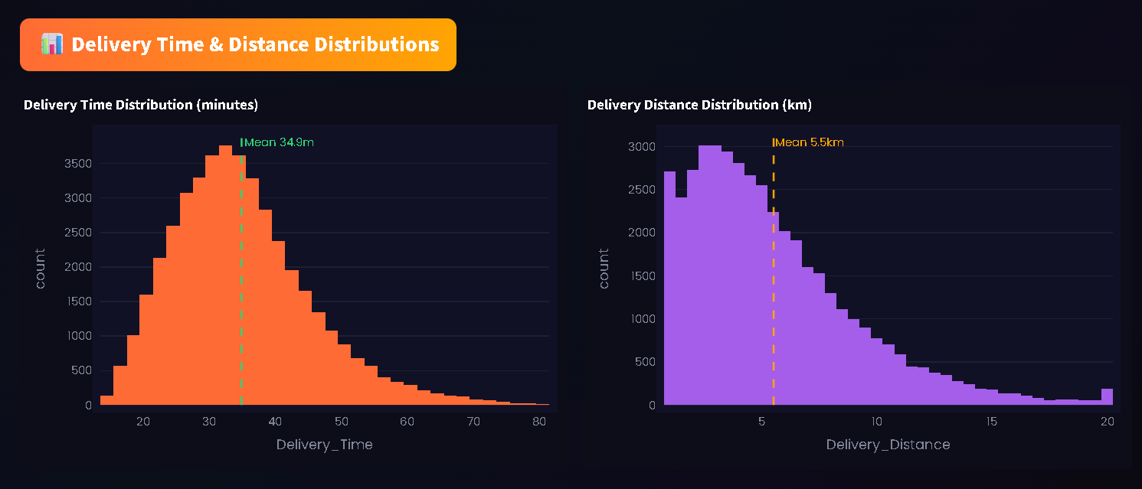

13. Customer Rating Analysis

Key Findings:
• Average customer rating: 4.11/5.0 — indicating generally high satisfaction.
• 5-star ratings are the most common, followed by 4-star. Distribution is left-skewed.
• Ratings are nearly uniform across food categories (~4.10–4.15/5.0), suggesting food type does not strongly influence satisfaction.
• Orders delivered within 0–25 minutes receive slightly higher ratings than those taking 45+ minutes.
• UPI payment orders have marginally higher ratings than Cash orders.
• Top-rated restaurants (min 50 orders) are spread across all 8 cities, with several achieving 4.3+/5.0 avg.
Charts: Rating distribution bar, Rating funnel chart, Avg rating by food category/cuisine, Delivery time bucket vs rating, Delivery time vs rating scatter, Rating by value segment, Rating by payment method, Top-rated restaurants bar.
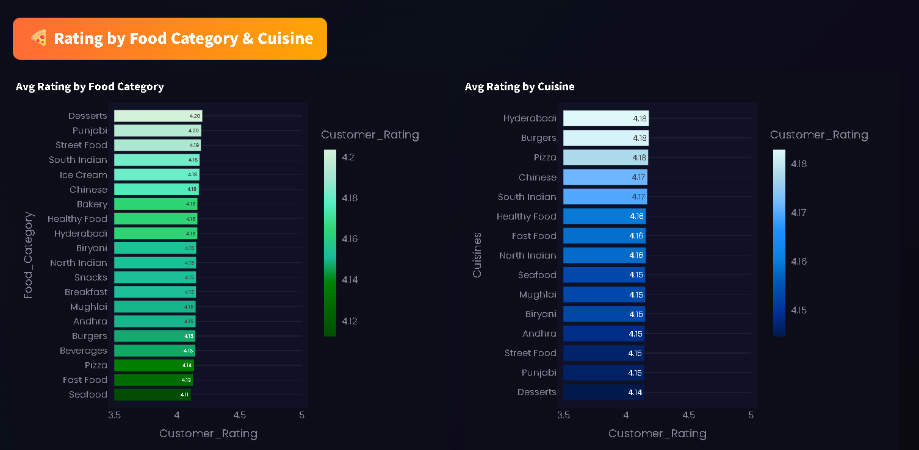

14. Dashboard Design & Features
The dashboard is designed with a premium dark theme and a vibrant multi-colour palette for maximum visual clarity and user engagement.

Design Features:
• Dark background: #0a0a0f with subtle gradient — reduces eye strain during analysis.
• Poppins font (Google Fonts): Clean, modern typeface across all text elements.
• Hero Banner: Every page opens with a full-width gradient banner (Red-Orange-Yellow-Green-Blue-Purple) showing the page title.
• KPI Cards: 8 bold gradient cards (Red, Orange, Yellow, Green, Blue, Purple, Pink, Teal) — each section of the KPI row has a distinct colour.
• Rainbow Dividers: 7-colour gradient lines separate each analysis section.
• Section Headers: Coloured pill-shaped badges (Red, Orange, Green, Blue, Purple, Gold, Teal) for every sub-section heading.
• Navigation: Quick-access coloured pill buttons at top of Overview page + styled sidebar radio buttons that glow on hover.
• Sidebar Filters: City, Order Status, Food Category, Date Range — all dynamically update every chart on the active page.
• Multiselect Tags: Vivid solid red (#e02020) with white bold text — high contrast on dark background.
• Chart Colour Scales: RED_SEQ, ORANGE_SEQ, GREEN_SEQ, BLUE_SEQ, PURPLE_SEQ, WARM, COOL, RAINBOW — each section uses a different palette.
• Interactive Slider: Top-N restaurants filter allows dynamic ranking comparison.
• OLS Trendline: Plotly's statsmodels-powered trendline on the Delivery Distance vs Time scatter.

Dashboard Pages Summary:
Page | Section Name | Key Charts Included
1 | Overview & KPIs | 8 KPI cards, Order Status pie, Payment pie, Data Quality bar, Monthly dual-axis trend
2 | Food Preferences | Category/cuisine bars, Revenue treemap, Value histogram, Segment pie, Quantity bars
3 | Time Analysis | Hourly dual-axis, Time of day, Weekday, Monthly area, Seasonal, Heatmap, Food by time stacked bar
4 | Customer Behaviour | Order freq histogram, Spend histogram, Segment pie, Segment spend bar, Fav food/cuisine bars, RFM scatter
5 | Restaurant & City | City orders bar, City bubble chart, Cuisine by city stacked, Top-N restaurants, Restaurant scatter, City rating bar
6 | Discount Behaviour | Discount comparison bar, Discount vs value scatter, Repeat rate bar, Rate vs spend scatter, Discount by category/cuisine
7 | Delivery Performance | Time/distance histograms, Distance vs time scatter (OLS), City time/delay bars, Delivery time by food category
8 | Rating Analysis | Rating distribution bar+funnel, Rating by food/cuisine/city, Time bucket vs rating, Value segment vs rating, Top-rated restaurants

15. Key Insights & Business Recommendations
Based on the analysis of 50,000 food delivery orders, the following insights and recommendations emerge:

Insight 1 — Peak Hours Are Evening & Night
Over 40% of all orders occur between 18:00–22:00. Recommendation: Focus marketing campaigns, promotional discounts, and restaurant staff allocation during these peak hours to maximise conversion rates.

Insight 2 — Weekends Drive Higher Volume
Saturday and Sunday consistently outperform weekdays. Recommendation: Launch weekend-exclusive combos and flash deals on Friday afternoons to drive early weekend engagement.

Insight 3 — 87.8% Repeat Buyers
The extremely high repeat rate indicates strong customer retention. Recommendation: Invest in a loyalty programme that rewards Gold-tier customers with exclusive perks to prevent churn of the highest-value segment.

Insight 4 — All Food Categories Are Balanced
No single food category dominates — all 20 categories receive similar order counts. Recommendation: Avoid over-investing in any single category; instead, ensure consistent quality and availability across all categories.

Insight 5 — Delivery Time Affects Ratings
Orders delivered within 25 minutes score slightly higher ratings. Recommendation: Prioritise route optimisation for orders in the 35–60 min delivery time bucket — even a 5-minute improvement could lift average ratings measurably.

Insight 6 — Discounts Attract Slightly Higher-Value Orders
Discounted orders have slightly higher avg value and quantity. Recommendation: Target discount campaigns at the ₹200–₹400 value segment to push customers into the ₹400–₹700 segment, increasing per-order revenue.

Insight 7 — UPI is the Dominant Payment Method
54.6% of orders use UPI. Recommendation: Ensure frictionless UPI integration and consider UPI-specific cashback offers to maintain and grow this payment segment.

16. How to Run the Project
Prerequisites: Python 3.9 or higher installed on Windows/Mac/Linux. The project file Kavana Shree V.py and the dataset archive (2).zip must be in the same folder.
Step 1 — Open a terminal (PowerShell / Command Prompt / Terminal) in the project folder.
Step 2 — Install dependencies: pip install -r requirements.txt
Step 3 — Launch the dashboard: python -m streamlit run "Kavana Shree V.py"
Step 4 — Open browser and navigate to: http://localhost:8502
Note: The first load may take 5–10 seconds while Streamlit processes the 50,000-row dataset. Subsequent interactions are fast due to @st.cache_data caching.

Project Files:
File | Description
Kavana Shree V.py | Main Streamlit dashboard application — all code in one file (1,306 lines)
requirements.txt | Python package dependencies (streamlit, pandas, numpy, plotly, statsmodels)
README.md | Full project documentation with steps, dataset description, and run instructions
archive (2).zip | Raw dataset ZIP containing swiggy_food_delivery_50000.csv

17. Conclusion
This project successfully delivers a comprehensive, interactive, and visually rich analytics dashboard that transforms 50,000 raw food delivery orders into clear, actionable business insights. The dashboard covers the full data analytics lifecycle — from raw data ingestion and cleaning through feature engineering, multi-dimensional analysis, and interactive visualisation.
The 8-page dashboard with 50+ interactive charts, dynamic filters, and segment-level drill-downs gives any business stakeholder — from a data analyst to a marketing manager — a complete 360-degree view of customer food preferences and delivery performance.
Key achievements of this project:
• 50,000 orders analysed across 8 cities, 15 cuisines, 20 food categories, and 19 months.
• 14-step structured analytics workflow from environment setup to final validation.
• 8 analytical dashboard pages with 50+ Plotly interactive charts.
• Fully dynamic sidebar filters (city, status, category, date range) — all charts update in real-time.
• Customer segmentation (Bronze/Silver/Gold) with RFM-style analysis.
• Premium multi-colour dark-theme UI with Poppins font, gradient KPI cards, and rainbow dividers.
Author: Kavana Shree V | IBM Internship — Data Analytics
File: Kavana Shree V.py | Dataset: Swiggy Food Delivery (50,000 Orders) | Tech Stack: Python · Streamlit · Plotly · Pandas

